Final Assessment:
- Set up Elastic SIEM and ingest log sources from: EC2 instances, AWS CloudTrail, VPC Flow Logs
- Integrate your SIEM with the AlienVault OTX Threat Intelligence platform.
- Enable out-of-the-box SIEM detection rules and create a custom detection rule to detect SSH access attempts to your environment.
- SSH into your EC2 instance to trigger the custom detection rule. From Elastic SIEM, contain the EC2 instance afterwards. The assumption here is that SSH activities are prohibited in your highly sensitive environment. So, a rule was created to detect such.
- Invite me (afseun@gmail.com) as an Organization Owner in your Elastic SIEM project for assessment.
- Create and submit an Incident Report (in PDF) documenting the detected SSH incident.
Deliverables (Each carries 20 marks):
- Invitation (signifies attendance and participation). Reach out to me via slack once invited, stating your email and full name.
- Functional Elastic SIEM deployment with required log sources.
- Configured threat intel integration (AlienVault OTX).
- Evidence of triggered custom SSH detection rule.
- Completed Incident Report (timeline, detection, triage, response actions) to be sent to me via slack
Submission Deadline: Thursday, 2nd October 2025 (11:59pm GMT+1)

Incident Report: Unauthorized SSH Access Attempt
Incident ID: INC-2025-SSH-001
Report Date: October 2nd, 2025
Author: Ojetokun Victor Ifeoluwa
AltSchool ID: ALT-SOE-024-2887
Status: Contained
Department: SOC-Tier 1 Unit
1. Executive Summary
On October 2, 2025 at approximately 3:00 PM, a successful SSH login was detected from an unauthorized public IP address (102.88.115.25) not associated with our organization's known IP ranges. The incident involved the user account ec2-user (AWS Cloud). The immediate actions were taken to secure the compromised account and investigate the extent of the breach. The investigation suggests a potential credential compromise.
2. Incident Timeline
Date | Time (UTC) | Event Description
October 2, 2025 | 15:00 | Initial Event: SSH login to AWS EC2 instance (172.31.24.129) from public IP (102.88.115.25)
October 2, 2025 | 15:05 | Detection: Alert triggered by the Security Information and Event Management (SIEM) system for login from the untrusted IP
October 2, 2025 | 15:15 | Initial Response: The on-call security analyst began the investigation
October 2, 2025 | 15:30 | Containment: The user account on AWS cloud was disabled, the active SSH session was terminated and instance isolated
October 2, 2025 | 15:35 | Investigation: Log analysis initiated to determine the scope of the attacker's actions

Scope of Impact
Affected System:
- Hostname: ec2-user
- EC2 Instance ID: i-0000f7f8cbbc70ee3
- IP Address: 172.31.24.129
Affected Account:
- Username: victor-ojetokun
Detection
- Detection Method: Custom Elastic SIEM detection rule.
- Rule Name: [HIGH SEVERITY] SSH Access Attempt Detected
- Rule Query: event.category: authentication and event.action:sshd
- Data Source: System logs from the /var/log/secure file, collected by the Elastic Agent.
Triage & Analysis
- Triggering Event: A successful SSH authentication event was logged by the SSHD service.
- Source: IP Address: 102.88.115.25. This IP was not on an allowed list.
- Target: EC2 Instance: i-0000f7f8cbbc70ee3, Hostname: ec2-user.
- Impact Assessment: As per the environment's security policy, SSH access is strictly prohibited. This activity constituted a direct policy violation and a potential unauthorized access attempt.
- Threat Intelligence: The source IP 102.88.115.25 was checked against AlienVault OTX
Response & Containment Actions
- Alert Review: The alert was immediately visible in the Elastic SIEM Alerts queue.
- Investigation: "View event details" function to see the full log context, confirming the source and target.
- Containment: Using the integrated response capabilities, I executed the "Isolate host" action directly from the alert, which issued a command through the Elastic Agent to block all network traffic on the host.
- Verification: The host's status was confirmed as "Isolated" in the Elastic SIEM Hosts overview, confirming the containment was successful.
Impact Assessment:
- Data Exfiltration: Under investigation, initial analysis of network traffic does not show large data transfers
- System Integrity: Log analysis is ongoing to check for unauthorized commands, file modifications, or malware installation
- Lateral Movement: No evidence of movement to other systems has been found at this time
Incident Details
- At 15:00 PM on October 2, 2025 an SSH connection was established to a critical EC2 instance running on IP 172.31.24.129. The connection was authenticated using the credentials for the ec2-user (Victor-Ojetokun) and originated from the public IP address 102.88.115.25.
- This activity triggered a high-priority alert because logins from non-VPN or non-office IP addresses are against security policy. The user, ec2-user (Victor-Ojetokun), was contacted and confirmed that he was not working at that time and did not initiate the login, indicating a credential compromise.
Response and Mitigation Actions
Immediate Actions:
- The active SSH session from the malicious IP was forcibly terminated
- The user account was immediately locked to prevent further access
- A security group rule was temporarily added to the EC2 instance to block all incoming traffic from the source IP 102.88.115.25
Ongoing Actions:
- A full audit of the commands executed during the session is underway
- The affected server is being scanned for malware and rootkits
- A password reset has been enforced for the user's account
6. Root Cause Analysis (Preliminary)
The preliminary root cause appears to be a compromised user credential. The method of compromise is still under investigation but could include phishing, password reuse, or malware on a personal device. The lack of mandatory multi-factor authentication (MFA) for SSH access was a contributing factor that allowed the attacker to gain access with only the password.
Recommendations and Next Steps
Immediate:
- Complete the forensic analysis of the affected server to determine the full extent of the attacker's actions
- Review logs for any similar access patterns across the infrastructure
Short-Term (1-2 Weeks):
- Enforce mandatory MFA for all SSH access to production environments
- Implement IP whitelisting for all administrative access to critical servers, restricting it to VPN and office networks
Long-Term (1-3 Months):
- Conduct a company-wide security awareness training session focusing on phishing and password security
- Deploy a privileged access management (PAM) solution to better control and monitor administrative access

Result
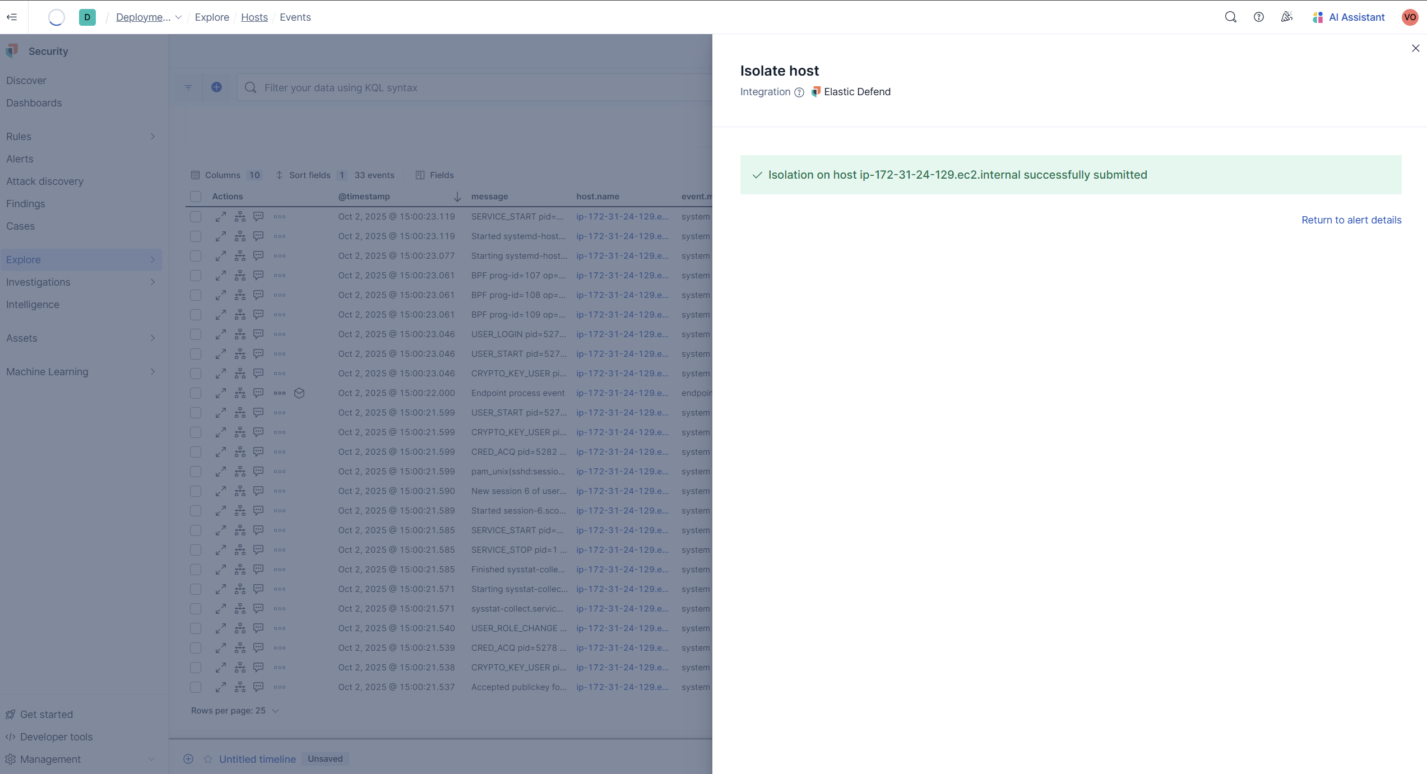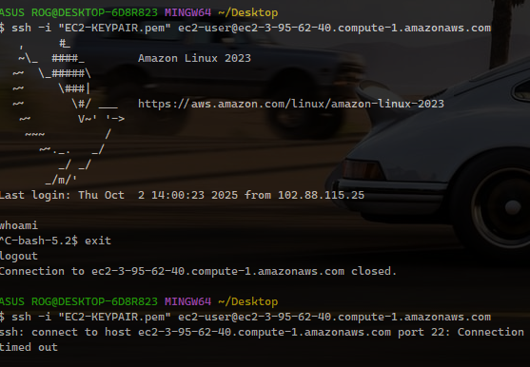

SSH Access Attempt detected
(event.dataset : "system.auth" OR agent.type : "filebeat") AND
(system.auth.ssh.event : "accepted" OR system.auth.ssh.event : "failed") AND
(system.auth.port : 22 OR destination.port : 22)

New Rule
event.module: "system" AND event.dataset: "system.auth" AND
(system.auth.ssh.event: ("accepted" OR "failed") OR message: "Accepted" OR message: "Failed password") AND
system.auth.ssh.port: 22
Discover: To query sshd actions: message: "*sshd*" OR system.auth.ssh.event:*

SSH DETECTION
(
event.dataset : "system.auth" AND
(system.auth.ssh.event : "accepted" OR system.auth.ssh.event : "failed") AND
(system.auth.port : 22 OR destination.port : 22)
)
OR
(
message : "*sshd*" AND
(message : "*Failed password*" OR message : "*Accepted password*")
)

